FLOOD FORECASTING USING ADAPTIVE RANDOM FOREST REGRESSION
Vaishnavi S¹, Shanmugapriaa VS², Shirisha K³, Yamani G4
1Assistant Professor, RMK college of Engineering and Technology
234Department of Computer Science and Engineering, RMK College of Engineering and Technology
1vaishnavicse@rmkcet.ac.in, 2 priaavs08@gmail.com, ³shirisha.kalahasthi@gmail.com,4princeyaminireddy@gmail.com

ABSTRACT
Floods are the maximum horrific herbal failures, which are instead elaborate to model. The research at the improvement of flood prediction fashions contributed to hazard bargain, insurance notion, minimization of the lack of human lifestyles, and good deal the assets damage associated with floods. To mimic the complicated mathematical expressions of physical techniques of floods, within the route of past a long time, gadget studying (ML) strategies contributed as a substitute withinside the development of prediction homes imparting higher customary typical performance and price powerful solutions. Due to the big blessings and functionality of ML, its reputation dramatically improved amongst hydrologists. Researchers through manner of introducing novel ML techniques and hybridizing of the prevailing ones desires intention at discovering greater accurate and inexperienced prediction techniques. The most vital contribution of this project is to demonstrate the US . Of the artwork of ML fashions in flood prediction and to offer prediction into the most wonderful fashions. In this task, the adaptive pc learning strategies had been benchmarked through qualitative assessment of robustness, speed, effectiveness, and accuracy are particularly investigated to offer an extensive keep in mind on the forecasting. The regular average overall performance evaluation of ML fashions offers an in-intensity grasp of the various techniques inside the framework of a entire evaluation and discussion. As a end result, this mission introduces the most promising random wooded area regression method for each long -term and brief-time period floods. Furthermore, the fundamental tendencies in enhancing the fantastic of the flood prediction fashions through the usage of adaptive modelling are investigated. This survey are frequently used as an offer for hydrologists in addition to local weather scientists in deciding on the right ML approach regular with the prediction undertaking.

KEY WORDS-Machine Learning, Random Forest Regression, Hydrologists, Adaptive Machine Learning

I.INTRODUCTION
Among the herbal disasters, floods are the most destructive, inflicting huge damage to human life, infrastructure, agriculture, and the socioeconomic system. Governments, therefore, are underneath stress to boost reliable and accurate maps of flood chance areas and in addition layout for sustainable flood chance management focusing on prevention, protection, and preparedness [1]. Flood prediction fashions are of sizable importance for hazard assessment and excessive event management. Robust and accurate prediction contribute exceptionally to water recourse management strategies, coverage recommendations and analysis, and further evacuation modeling [2]. Thus, the importance of advanced systems for temporary and long-term prediction for flood and different hydrological activities is strongly emphasized to alleviate damage [3]. However, the prediction of flood lead time and incidence location is largely complex due to the dynamic nature of neighborhood weather condition. Therefore, today’s main flood prediction fashions are commonly data-specific and involve more than a few simplified assumptions [4]. Thus, to mimic the complicated mathematical expressions of bodily approaches and basin behavior, such fashions advantage from unique techniques e.g., event-driven, empirical black box, lumped and distributed, stochastic, deterministic, continuous, and hybrids [5].

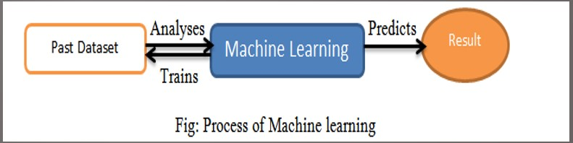

II. LITERATURE SURVEY

1.Title: Flood Prediction Using Machine Learning Models: Literature Review

Authors: Amir Mosavi, Pinar Ozturk and Kwok-wing Chau
Journal Name: Applied Software Computing

Volume and Year: Vol. 21, 2018
Description: The modern nation of ML modeling for flood prediction is pretty younger and inside the early degree of advancement. This paper affords an outline of system learning models used performance evaluation of unmarried methods for long-time period PBIAS R2 in flood prediction, and develops a class scheme to investigate the present literature. The survey represents the performance evaluation and investigation of extra than 6000 articles. Among them, we recognized a hundred and eighty unique and influential articles in which the performance and accuracy of at the least two gadget studying fashions were compared. To do so, the prediction models were categorized into classes in keeping with lead time, and in addition divided into classes of hybrid and single methods. The state of the artwork of those training changed into discussed and analyzed in detail, thinking about the overall performance contrast of the strategies available in the literature. The overall performance of the techniques became evaluated in phrases of R2 and PBIAS, similarly to the generalization ability, robustness, computation cost, and speed. Despite the promising outcomes already stated in enforcing the maximum popular machine gaining knowledge of methods, e.g., ANNs, SVM, SVR, RF, WNN, and DTs, there was substantial research and experimentation for in addition improvement and advancement. In this context, there were four most important tendencies suggested within the literature for improving the exceptional of prediction.

2.Title: An evaluation of adaptive surrogate modeling-based optimization with two benchmark problems
Authors: Chen Wang, Qingyun Duan, Wei Gong, Aizhong Ye, Zhenhua Di, Chiyuan Miao
Journal Name: Environmental Modelling & Software

Volume and Year: Vol. 60, 2014

Description: This have a look at evaluates an adaptive surrogate modeling-based optimization (ASMO) method on two benchmark issues: the Hartman function and calibration of the SAC-SMA hydrologic version. The outcomes show that: 1) Gaussian Processes are the quality surrogate version creation technique. A minimum Interpolation Surface technique is the first-class adaptive sampling method. Low discrepancy Quasi Monte Carlo methods are the maximum appropriate initial sampling designs. Some 15e20 times the size of the trouble may be the right preliminary sample size; 2) The ASMO approach is a superb deal more green than the broadly used Shuffled Complex Evolution international optimization techniques. However, ASMO can offer best approximate choicest answers, whose precision is confined via surrogate modeling techniques and trouble-unique functions; and three) The identifiability of version parameters is correlated with parameter sensitivity.
3. Title: Flexible consumer interface for machine getting to know techniques to enhance the complex geospatial hydro-climatic models with destiny perspective.
Authors: Venkatesh Budamala & Amit Baburao Mahindrakar

Journal Name: Geocarto International

Volume and Year: Vol. 50, 2020

Description: Hydro-climatic (HC) models have complicated environments because of the combination of hydrological approaches and climate indices for the assessment of ancient and future scenarios. The approximation of HC models results in a prime uncertainty within the selection of choicest techniques for processing, enhancement, and evaluation. The gift work evolved a User-Friendly Interface (UI) inside the R programming platform to beautify the geospatial HC fashions the use of device learning principles. Here, UI complies with various technology collectively to carry out continuously with input manipulate, processing, and visualization. To validate this interface, a snow dominated alpine watershed turned into decided on. The results showed that, (a) UI assisted to downscale of the destiny climatic data into finer decision, (b) boosted the efficiency of the geospatial version through adaptive random woodland regression with NSE¼0.92 and zero.84, respectively.
4. Title: Hybrid machine learning hydrological model for flood forecast purpose
Authors: Guangyaunkan, KeLiang, Haijun Yu
Bowen Sun, Liuqian Ding
Journal Name: Open Geosciences

Volume and Year: Vol. 45, 2020

Description: Machine mastering-based information-pushed fashions have carried out superb fulfillment considering their invention. Nowadays, the synthetic neural network (ANN)- based totally system getting to know methods have made awesome progress than ever before, consisting of the deep gaining knowledge of and reinforcement getting to know, and so forth. In this look at, we coupled the ANN with the K-nearest neighbor approach to propose a singular hybrid system studying (HML) hydrological version for flood forecast cause. The gain of the proposed model over traditional neural network fashions is that it is able to expect discharge continuously without accuracy loss owed to its specifically designed version structure. In order to conquer the local minimum trouble of the conventional neural community training, a genetic set of rules and Levenberg–Marquardt-based multi-objective education technique changed into also proposed. Real-worldwide programs of the HML hydrological model suggest its first-class overall performance and dependable balance, which enlightened the possibility of further programs of the HML hydrological model in flood forecast problems.
5.Title: Prediction Analysis of Floods Using Machine Learning Algorithms (NARX & SVM)
Authors: Nadia Zehra
Journal Name: International Journal of Sciences: Basic and Applied Research
Volume and Year: Vol. 49, 2020
Description: The converting styles and behaviors of river water degrees that could cause flooding are an interesting and practical studies place. They are configured to mitigate monetary and societal implications delivered approximately by way of floods. Non-linear (NARX) and Support Vector Machine (SVM) are gadget mastering algorithms suitable for predicting adjustments in ranges of river water, for that reason detection of flooding possibilities. The two algorithms rent comparable hydrological and flood aid variables which includes precipitation amount, river influx, top gust, seasonal flow, flood frequency, and different applicable flood prediction variables. In the technique of predicting floods, the water level is the most vital hydrological research component. Prediction using machine- learning algorithms is powerful because of its functionality to make use of facts from diverse assets and classify and regress it into flood and non-flood classes. This paper gives insight into mechanism of the 2 algorithms in perspective of flood estimation. The gain of the proposed version over conventional neural network models is that it could expect discharge constantly without accuracy loss owed to its particularly designed model structure. In order to overcome the neighborhood minimal problem of the traditional neural network schooling, a genetic set of rules and Levenberg–Marquardt-based multi-goal schooling method.

III. IMPLEMENTATION

Problem Definition:
River drift forecasting has constantly been one of the most necessary issues in hydrology and it is an essential measure in water aid development and planning. Forecasting a river drift provides a warning of impending degrees all through floods and assists in regulating reservoir outflows in the course of low river flows for water useful resource management. To date, a plethora of rainfall-runoff models belonging to one of a kind classes is handy for drift forecasting purposes. Most of the rainfall-runoff models have been developed primarily based either on physical considerations of the process or on a structures theoretic approach. In the physical approach, the most important motivation is the learn about of bodily phenomena and their understanding, while in the gadget theoretic method the situation is with the device operation, no longer the nature of the device by using itself or the bodily legal guidelines governing its operation.
IV. EXISTING SYSTEM
Traditionally, autoregressive moving common (ARMA) models have been used for modelling and forecasting water resource time series because such models are popular as a fashionable illustration of a stochastic time series. The method that is based totally on a statistical approach makes use of classical records to investigate the historic records with an goal to bolster strategies for the components of flood forecasts. However, such fashions do now not try to signify the nonlinear dynamics inherent in the transformation of rainfall to runoff and consequently may additionally now not continually operate well. Owing to the difficulties related with non linear mannequin shape identification and parameter estimation, very few sincerely nonlinear systems theoretic watershed models have been reported.
Traditionally applied modelling methods be refined or complemented to reap accelerated overall performance via imposing new or exclusive technologies. During the ultimate two decades, the tools that engineers and scientists work with have extended significantly. The rapid increase of computing strength has enabled the researchers to boost fantastic modelling tools. One of the most exciting ideas that emerged from the massive pool of computer-based research is the thinking of emulating the low-level mechanism of the human brain via synthetic neural networks (ANN). Already, beneficial purposes have been designed, constructed and commercialized, and tons lookup continues in the hope of extending this success. Similarly, the fuzzy rule-based strategy in modelling, in a range of fields of science and technology. The cause for such an growing activity resides in their intrinsic generality, flexibility, and world performance in most purposes the place other models both have a tendency to fail or end up cumbersome. Both these smart computing methods have far-reaching workable as constructing blocks in today’s computational world.

V.PROPOSED SYSTEM
Project addresses the problem of forecasting the river go with the flow on the muse of rainfall and runoff facts. The goal of the paper changed into as soon as twofold: one became to expose the potential of the Random Forest Regression (RF) computing paradigm in modelling the rainfall-runoff procedure; and 2d become once to assess the relative merits and demerits of this paradigm on the subject of already well-known SVM, ANN and GP modelling approaches. The find out about indicates that the RF model is capable of capture the inherent nonlinearity in the rainfall-runoff approach higher than the one-of-a-kind 3, and is able to forecast flows satisfactorily up to 5 hours earlier. A very close healthy became as soon as received among computed and observed flows up to 1 hour in growth for all fashions, however totally the RF tends to maintain this overall performance at higher lead times. A comparative evaluation of prediction accuracy of these models in incredible levels of drift indicates that the RF is better than the ANN, SVM.

V. METHODOLOGY

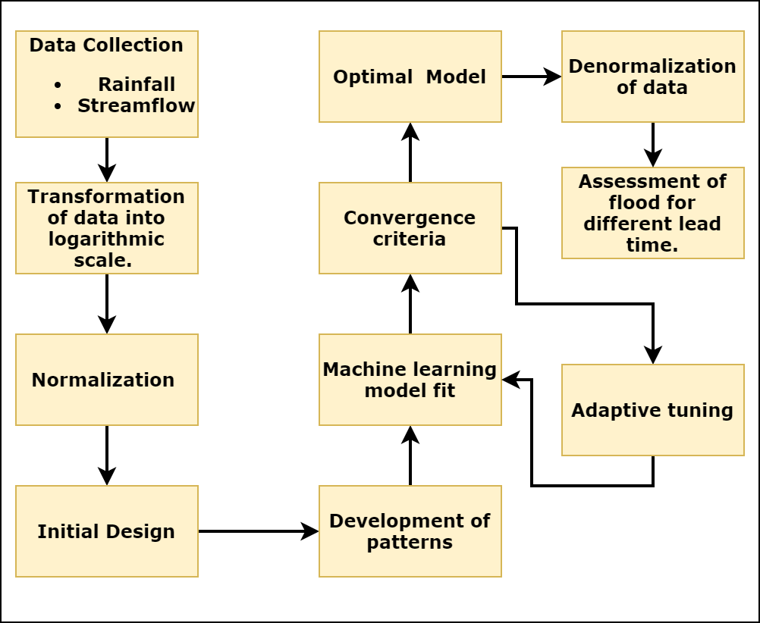
Figure 3.1 –Framework forecasting using adaptive random forest regression

The adaptive system mastering framework to obtain the most efficient flood forecasting was based totally on the following essential components (Fig 3.1):
• Acquisition of version inputs.
• Preprocessing of inputs by way of statistical way to stumble upon redundancy.
• Development of machine getting to know model.
• Convergence standards test of gadget gaining knowledge of version predictions.
• Assessment of the most suitable version.
• Analyzing the flood predictions for different lead instances
SELECTION OF INPUTS TO THE MODEL
One of the most critical steps within the version development procedure is the determination of vast enter variables. Usually, now not all of the potential enter variables can be equally informative for the reason that some may be correlated, noisy or don't have any sizeable courting with the output variable being modeled. Generally, a few diploma of a priori know-how is used to specify the preliminary set of candidate inputs to the basin.
• Although a concern identification is broadly used in many packages and is essential to define a candidate set of inputs, it is depending on an expert’s understanding, and therefore is very subjective and case-based. Intuitively, the favored technique for figuring out appropriate inputs and lags of inputs, includes a aggregate of a priori information and analytical strategies. When the connection to be modeled isn't always well understood, then ananalytical method, along with cross correlation, is frequently employed. The important drawback related to the usage of cross correlation is that it's miles most effective capable of locate linear dependence among variables. Therefore, go correlation is unable to capture any nonlinear dependence that can exist between the inputs and the output, and may probable result in the omission of critical inputs that are associated with the output in a nonlinear fashion. While reviewing the present day kingdom of input selection tactics in water sources packages, file that the cross-correlation methods represent the maximum popular analyticaltechniques for selecting suitable inputs. It follows that there is right scope for addressing this problem in destiny studies.
The contemporary examine employed a statistical approach to come to be aware about the right enter vector. The approach is based totally on the heuristic that the capacity influencing variables similar to outstanding time lags can be recognized thru statistical evaluation of the statistics collection that makes use of skip correlation, autocorrelation, and partial autocorrelation a few of the variables in question. The move correlation among the runoff and rainfall series at numerous lags showed extremely good correlation at 1,2 and three hours of rainfall lag at the flow at any time. The autocorrelation and partial autocorrelation function advocate a widespread correlation, at 90 five% self perception level up to at least one hour of runoff lag. As said in advance, 4 varieties of fashions had been developed on this examine, especially, Random Forest Regression (RFR), Support Vector Machines (SVM), Artificial Neural Networks (ANN) and Gaussian Process (GP) all of them constructed the use of the identical enter variables.
RANDOM FOREST REGRESSION
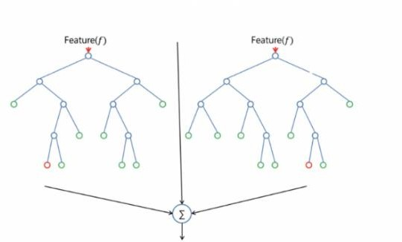
Random forests are one of ensemble techniques. The purpose of ensemble methods is to combine the predictions of numerous models built with a given getting to know set of rules with the intention to improve generalizability and robustness over a unmarried version. Random forests are getting to know ensemble consisting of a bagging of un- pruned selection tree inexperienced persons with a randomized choice of capabilities at each split. The random forests set of rules is as follows: 1) provident tree bootstrap samples from the unique facts; 2) for every of the bootstrap samples, grow a regression tree with the following amendment: at every node, rather than choosing the great cut up amongst all predictors, randomly pattern strive of the predictors and pick the excellent cut up from among those variables; 3) predict new records via aggregating the predictions of the timber

Figure-Architecture of Random Forest Regression

VII.SYSTEM ARCHITECTURE

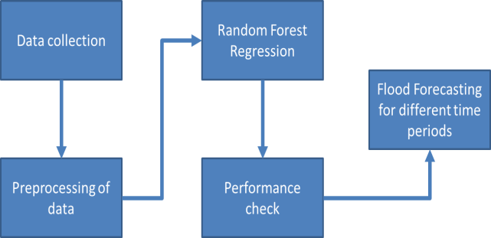
Figure- System Architecture Diagram for Flood Forecasting
VIII.RESULT AND ANALYSIS
The results and discussions broadly divided into two phases like “Phase – 1 (for model selection) and Phase – 2 (for model stability)”.
Phase – 1 (Assessment of Adaptive Random Forest Regression with comparison of different machine learning methods)
Different steps are worried in growing adaptive modelling like initial design, regression, convergence criteria and adaptive sampling (if required). One of the most important difficulties within the pseudo modelling is placing preliminary layout. Basically, the initial layout contains of inputs (adjustable parameters) and outputs (goal function), wherein The adjustable parameters are decided on based totally at the Sobol sensitivity analysis. Here, screened out the 10 most influential parameters that are inducing the version output and considered as inputs to the pseudo modelling with NSE because the objective characteristic(output). For deciding on the volume of preliminary layout,
Next goal is to select the first-class most desirable version with the required initial design. To show the relation among the preliminary placing to the special device mastering models, Fig. Depicts the person overall performance of each model with various the lead times. GP and SVM tended to boom the prejudice whilst various the lead time sizes, however ANN carried out the applicable performances and it can't follow any trend in its fitting. Among the four techniques, Random Forest furnished the exceptional implementations over the other strategies in exclusive preliminary setting because of its several hyper parameters and reinforcement gaining knowledge of. Therefore, the Machine learning model (i.E, RF) taken into consideration as first-rate implementation techniques. Our foremost objective is to show the maximum appropriate sample for the choice of methods to optimize flood thru Random Forest modelling. In Fig .8.1 , it simply suggests the pattern with an effective answer for reaching the performance.
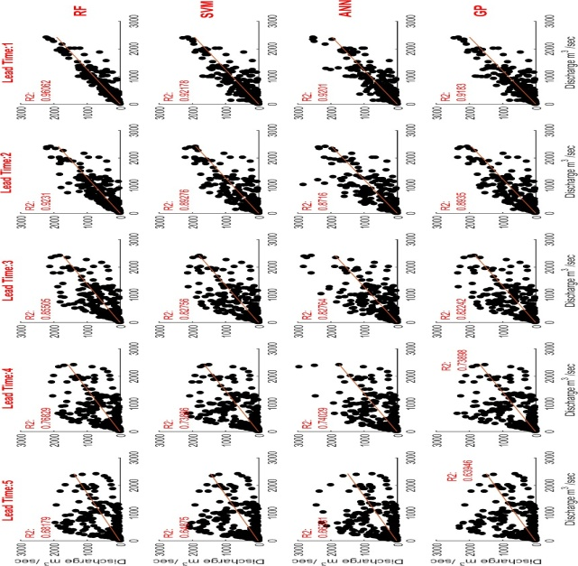
Figure 8.1-Comparison of Random Forest Regression with different Machine Learning models during calibration timestep by varying lead times.
Phase – 2
The conventional machine studying exams the model convergence with none future updates and manage of sampling. The adaptive random woodland regression- primarily based optimization restricts the samples and helps to computational burden.
Performance-wise
Nash-Sutcliffe performance (NSE), Percentage of Bias (PBIAS) and Coefficient of willpower (R2) had taken to evaluate the watershed models for both calibration and validation. Figure 8.1 and 8.2 shows the scores of overall performance metrics for stream flow prediction and it's far honestly showed that > zero Sixty five NSE, ≤
± 10 PBIAS, shows a terrific model. So, the above standards set as a threshold restrict for the comparison of all of the models. Based on the brink restrict of NSE and PBIAS, RF completed first-class performances, and last methods aren't able to offer close to threshold. Finally, it's far vivid that adaptive approach yields the fine performances over one-shot approach for prediction of flood.
Sample-wise
For putting the most number of samples used a hundred instances of parameter dimensions i.e., a hundred* 10 = a thousand. Based on Sec. Three.1, the adaptive strategy seized the samples within 250. While ultimate fashions approached the most limits. It is not important to attain for the whole set and sufficient to gain important units. As sample length increases computational burden can growth. For powerful manipulate of samples, the adaptive sampling able to limit the parameter units and make tons more computationally efficient.
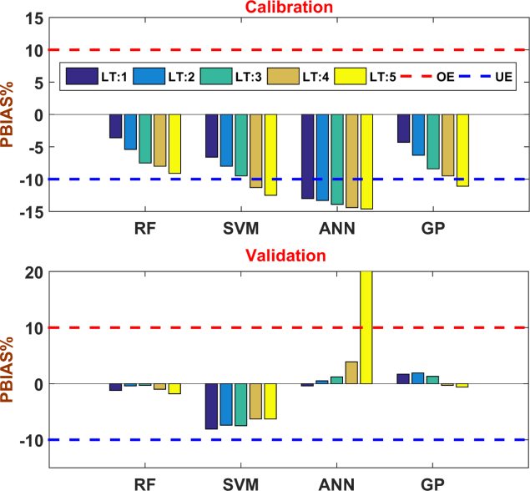
Figure 8.2-Comparison of NSE performance indicator for Random Forest Regression with different Machine Learning models during calibration and validation timestep by varying lead times.

Analysis Of Flow
For evaluation of flows used varieties of plots like hydrograph and Flow- Duration Curves (FDC). These plots show accurately whether a model able to seize peaks and base flow or now not. The correct prediction of peaks facilitates for floods, and base waft prediction beneficial for drought situations. A hydro graphics a plot between
Figure-Comparison of different flows for RF, SVM,
ANN and GP using Flow Duration Curve’s (FDC) for both calibration and validation

Time - period Vs. Discharge for both calibration and validation (Fig. 10). As looking at in, all models followed a similar fashion, however adaptive method almost coincides with found values in each peaks and base waft .FDC plots can divide into special categories like excessive flows (0toQ20), medium flows (Q20 to Q75), low flows (Q75 to Q90), and very low flows (Q90 to Q100), this category additionally referred to as go with the flow signatures. According to flow signatures, high flows contained little variation to the located data of all models and ultimate flow has captured the discovered facts.
Moreover an adaptive approach is toward found data in all kinds of flows compared to last fashions. Therefore, APMO proved it’s great in all sections of assessment.
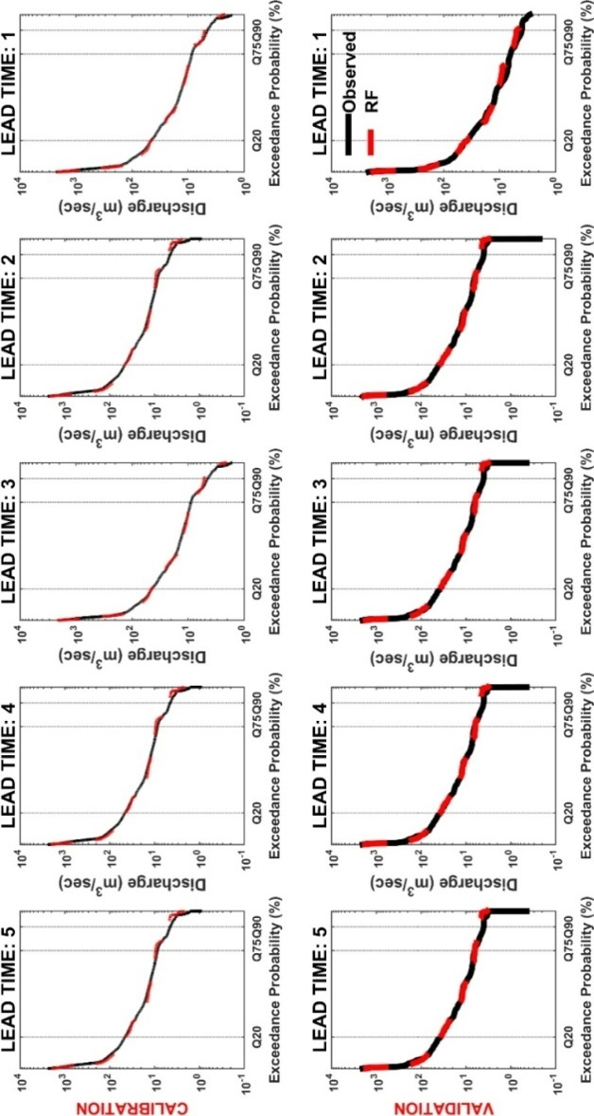

V11.CONCLUSION

The goal of this research to provide accurate flood prediction analysis with less computational burden. To improving the efficiency of flood forecasting proposedAdaptive Random Forest Regression. The proposed model with help of future climatic data can provide information of future water use, water demand, water management and nature water related disasters like floods and droughts for decision makers, planners, engineers and scientists.

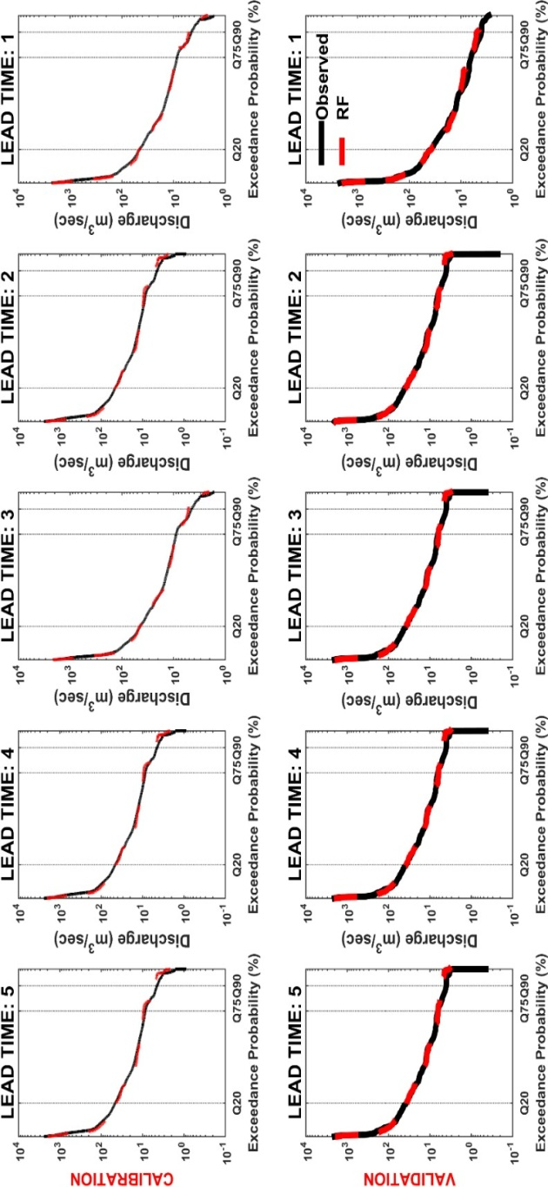
V111.FUTURE WORKS

Adaptive Random Forest Regression framework can be applicable for different topographical and climatic variability watersheds. In future research, we concentrate on the multivariable with spatial optimization for identification of approximate hydrological process. This framework not only limited to optimization of hydrological models but also applicable to different streams and sectors like Aerodynamics, Bio-Informatics, Earth studies, Economics, Electronics and Water Resources Engineering etc., It is to be noted that some other machine mastering model may be followed as approximate function including like Kriging, Radial Basis Function, Extreme Learning Machines and Multivariate Adaptive Regression Splines.

XI.REFERENCES
1.Danso-Amoako, E.; Scholz, M.; Kalimeris, N.; Yang, Q.; Shao, J. Predicting dam failure danger for sustainable flood retention basins:
2.Xie, K.; Ozbay, K.; Zhu, Y.; Yang, H. Evacuation region modeling underneath climate exchange: A data-driven technique. Journal of Infrastructure Systems 2017, 23, 1-nine.
3. Pitt, M. Learning classes from the 2007floods. Cabinet Office London:2008.
4. Lohani, A.K.; Goel, N.; Bhatia, K. Improving actual time flood forecasting using fuzzy inference device. Journal of hydrology 2014, 509, 25-forty one.
Five.Patro, S.; Chatterjee, C.; Mohanty, S.; Singh, R.; Raghuwanshi, N. Flood inundation modeling the use of mike flood and remote sensingdata. Journal of the Indian Society of Remote Sensing 2009, 37, 107-118.
6.Zhao, M.; Hendon, H.H. Representation and prediction of the indian ocean dipole within the poama seasonal forecast model. Quarterly Journal of the Royal Meteorological Society 2009, a hundred thirty five, 337-352.
7.Liang, X.; Lettenmaier, D.P.; Wood, E.F.; Burges, S.J. A simple hydrologically based totally model of land floor water and strength fluxes forgeneral move fashions. Journal of Geophysical Research: Atmospheres 1994, 99, 14415-14428.
8.Nayak, P.; Sudheer, K.; Rangan, D.; Ramasastri, K. Short-term flood forecasting with a neurofuzzy version. Water Resources Research 2005, forty one.
9.Kim, B.; Sanders, B.F.; Famiglietti, J.S.; Guinot, V. Urban flood modeling with porous shallow-water equations: A case examine of model errors within the presence of anisotropic porosity. Journal of Hydrology 2015, 523, 680-692.
10.Van den Honert, R.C.; McAneney, J. The 2011 brisbane floods: Causes, impacts and implications. Water 2011, three NOT PEER-REVIEWED 5 October 2018 doi:10.20944/preprints201810.0098.V1.
11. Lee, T.H.; Georgakakos, K.P. Operational rainfall prediction on meso- γ scales for hydrologic packages. Water Resources Research 1996, 32, 987-1003.
12.Shrestha, D.; Robertson, D.; Wang, Q.; Pagano, T.; Hapuarachchi, H. Evaluation of numerical climate prediction model precipitation forecasts for quick-time period streamflow forecasting reason. Hydrology and Earth System Sciences 2013, 17, 1913-1931.
13.Valipour, M.; Banihabib, M.E.; Behbahani, S.M.R. Parameters estimate of autoregressive moving average and autoregressive integratedmoving average fashions and examine their potential for inflow forecasting. J Math Stat 2012, 8, 330-338.
14.Adamowski, J.F.C., Hiu; Prasher, Shiv O; Ozga-Zielinski, Bogdan; Sliusarieva, Anna. Comparison of a couple of linear and nonlinear regression, autoregressive included transferring common, synthetic neural community, and wavelet artificial neural network methods for city water demand forecasting in montreal, canada. Water Resources Research 2012, 48.
15.Valipour, M.; Banihabib, M.E.; Behbahani, S.M.R. Comparison of the arma, arima, and the autoregressive synthetic neural community fashions in forecasting the monthly influx of dez dam reservoir. Journal of Hydrology 2013, 476, 433-441.
16.Chow, V.T.; Maidment, D.R.; Larry, W. Mays. Applied hydrology.International edition, MacGraw-Hill, Inc 1988, 149.
17.Aziz, K.; Rahman, A.; Fang, G.; Shrestha, S. Application of synthetic neural networks in regional flood frequency evaluation: A case take a look at for australia. Stochastic environmental studies and danger evaluation 2014, 28, 541-554.
18.Kroll, C.N.; Vogel, R.M. Probability distribution of low stream flow series inside the u.s.. Journal of Hydrologic Engineering 2002, 7, 137-146.
19.Mackey, B.P.; Krishnamurti, T. Ensemble forecast of a typhoon flood event. Weather and forecasting 2001, 16, 399-415.
20.Haddad, K.; Rahman, A. Regional flood frequency evaluation in japanese australia: Bayesian glsregression primarily based techniques inside constant region and roi framework–quantile regression vs. Parameter regression technique. Journal of Hydrology 2012, 430, 142-161.
21.Thompson, S.A. Hydrology for water management. CRC Press: 2017.
22.Kerkhoven, E.; Gan, T.Y. A modified isba floor scheme for modeling the hydrology of athabasca river basin with gcm-scale records. Advances in water assets 2006, 29, 808-826.
23.Burnash, R.J.; Ferral, R.L.; McGuire, R.A. A generalized streamflow simulation gadget,conceptual modeling for virtual computer systems. 1973.
24.Yamazaki, D.; Kanae, S.; Kim, H.; Oki, T. A bodily based description of floodplain inundation dynamics in a worldwide river routing model. Water Resources Research 2011, 47.
25.Fawcett, R.; Stone, R. A contrast of seasonal rainfall forecasting systems for australia. Australian Meteorological & Oceanographic Journal 2010, 60, 15-24.

